Q1🡪

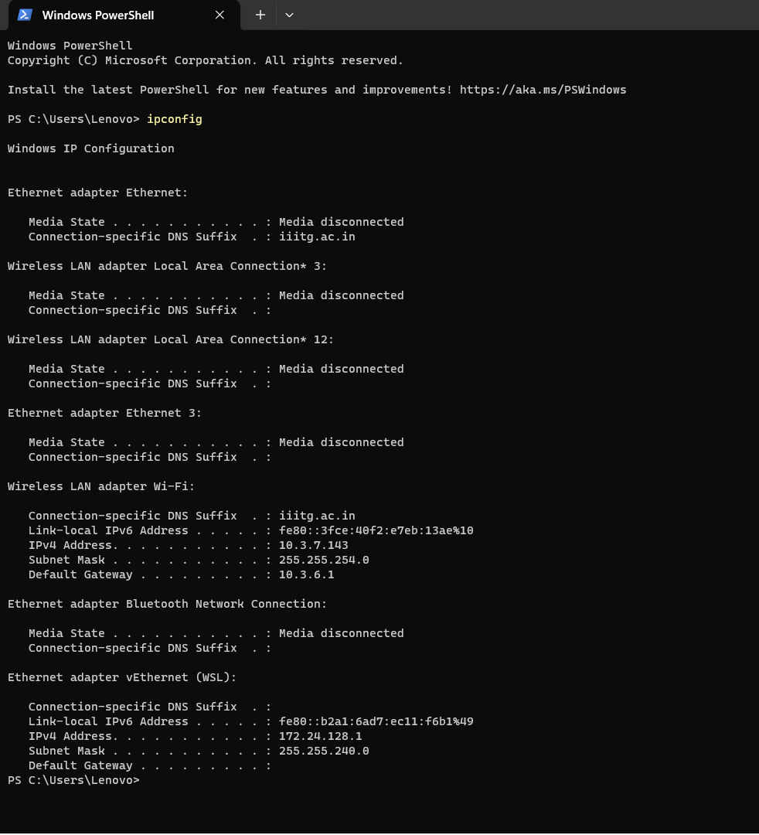

Q🡪2

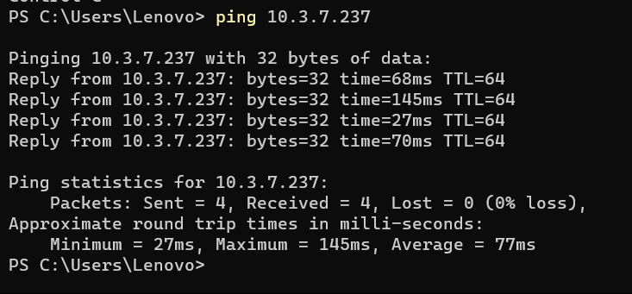

Q3🡪

First Address of network

Q4🡪

Yes, the external IP address you see on "whatismyip.com" is the address that represents your entire local network on the internet, while the internal IP address from ipconfig is the address specific to your individual device within your local network.

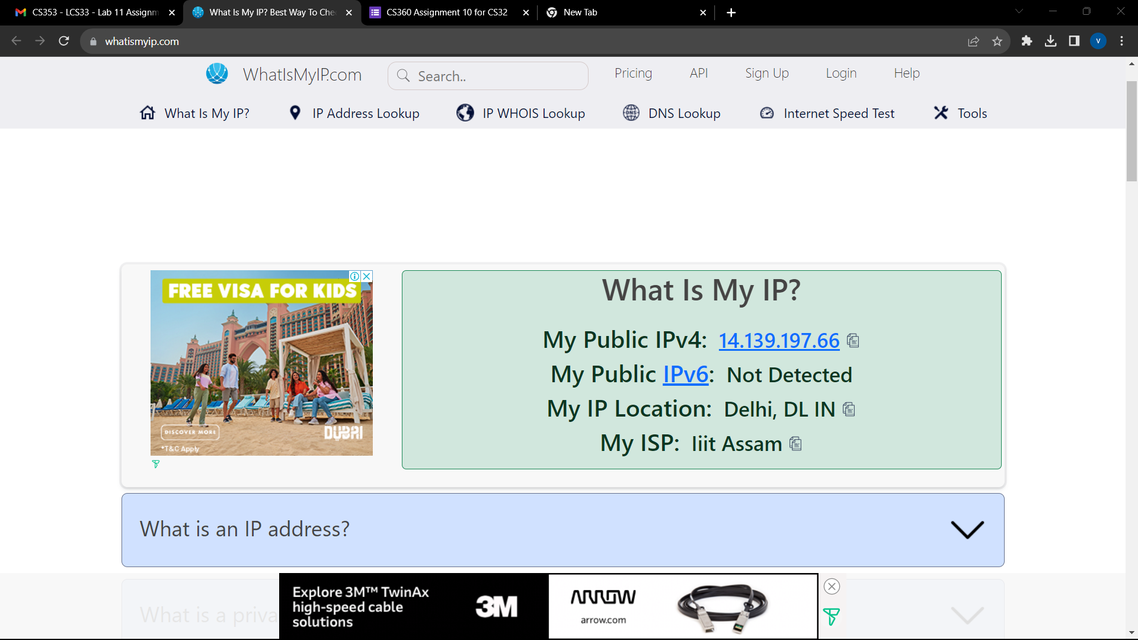

Q5🡪

NKN-CORE-NW NKN Core Network, IN

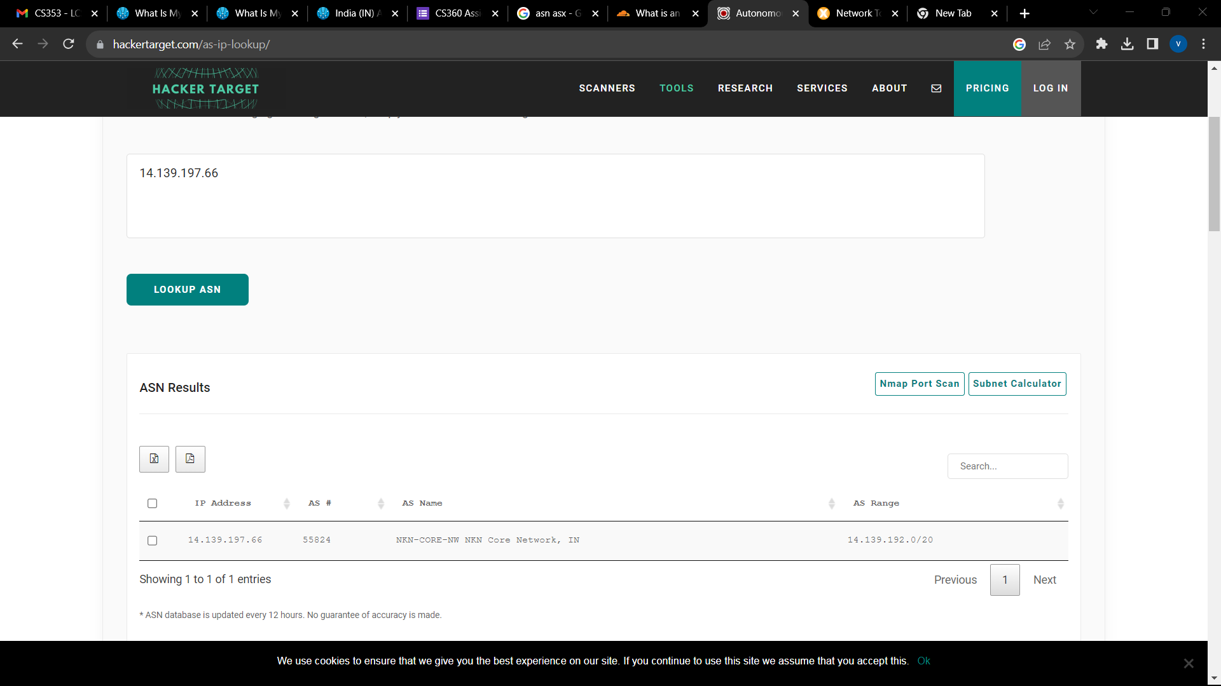

Q6🡪

My ISP is Iiit Assam

Q7🡪

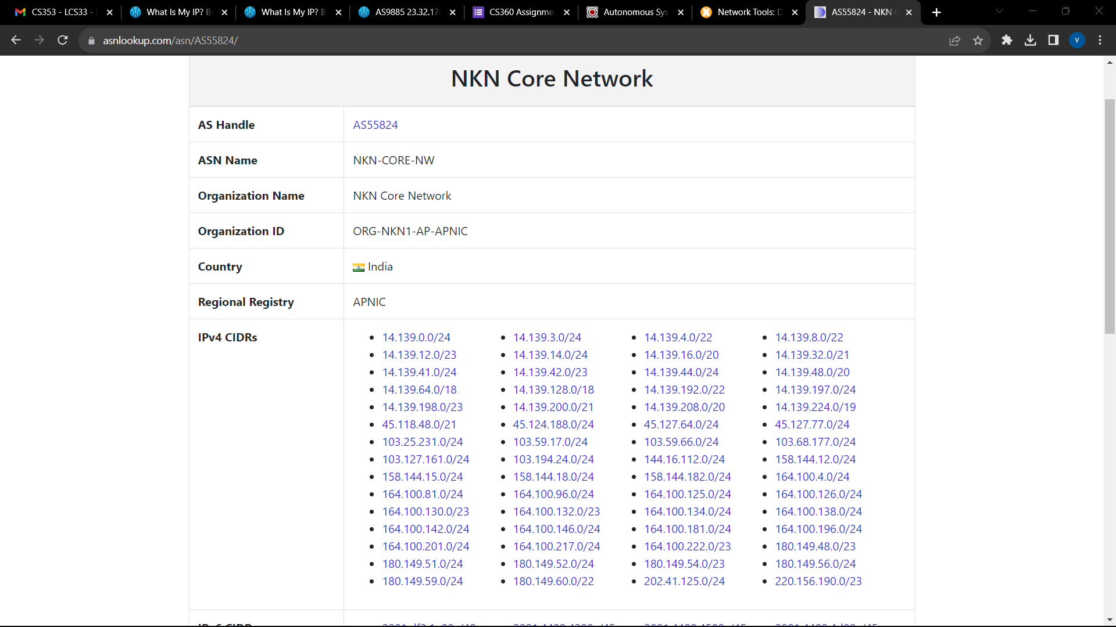

Q8🡪

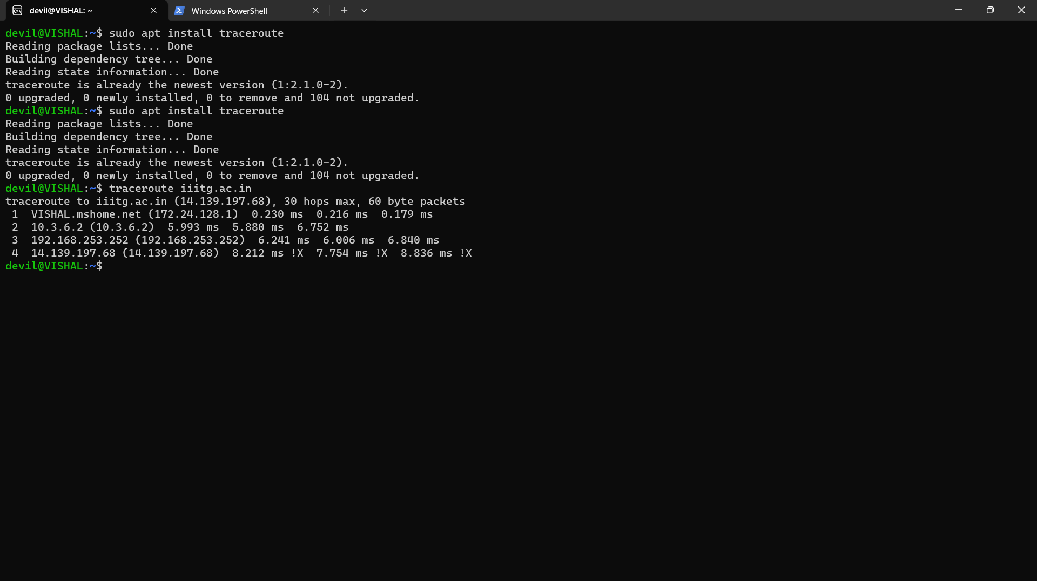

The traceroute or tracert command will start probing the route to the specified domain, and it will display a list of hops along the way with information about each hop. The information typically includes the IP address of each router or server along the path, as well as the response times for each hop. Here's what you might see in the output:

The first entry is usually your own local router or gateway.

Subsequent entries represent intermediate routers and servers that the data packets pass through on their way to the destination.

Each entry typically includes the IP address of the router or server and a series of response times measured in milliseconds. The response times indicate the time it took for a packet to travel from your computer to that specific router or server and back.

The domain name, if available, is also displayed for each hop along with the IP address.

The final entry is the destination host or domain, in this case, "iiitg.ac.in."

The purpose of using traceroute or tracert is to diagnose network issues and identify potential bottlenecks or delays in the network path. It helps you understand the route your data takes and can be useful for troubleshooting connectivity problems.

Q🡪9



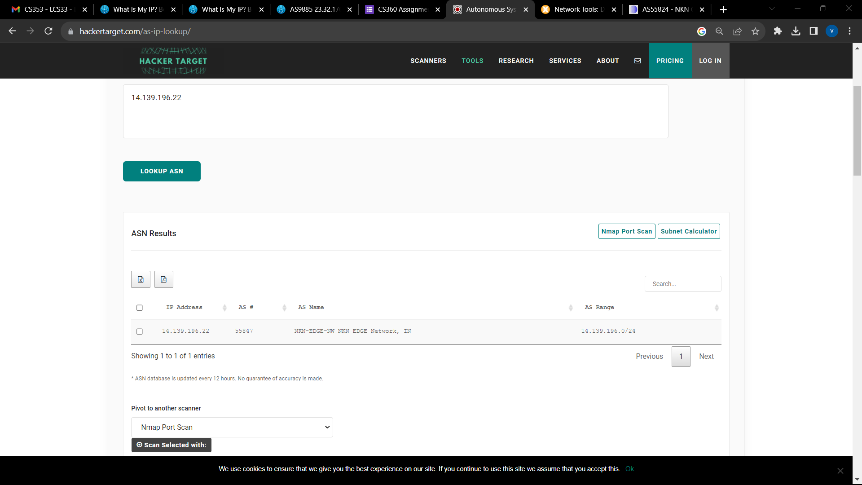

No, they do not belong to the same ASN.

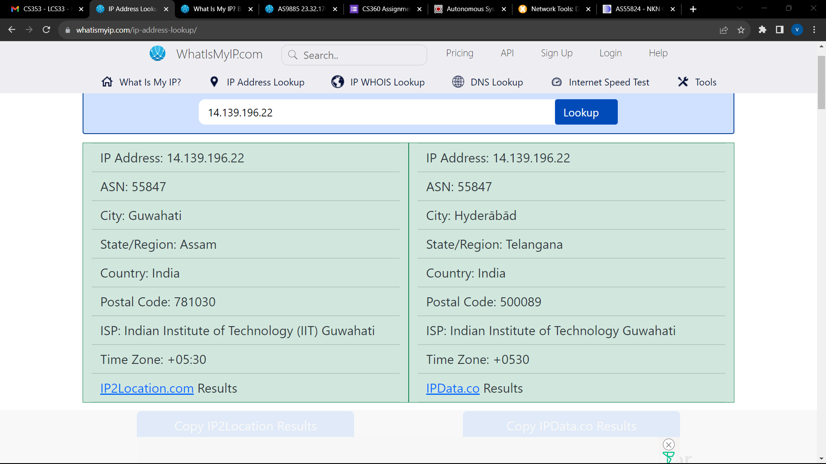

Q10🡪

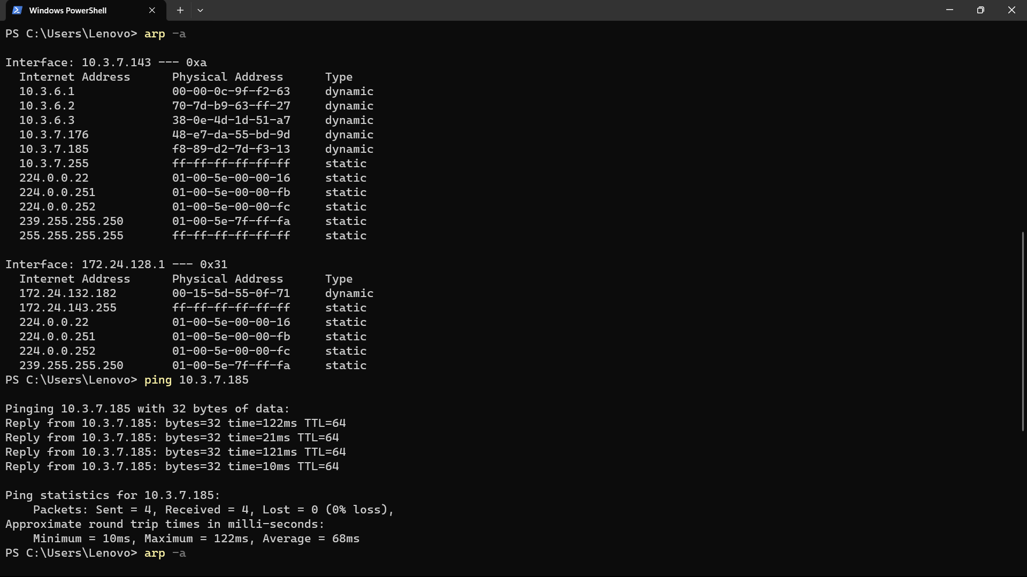

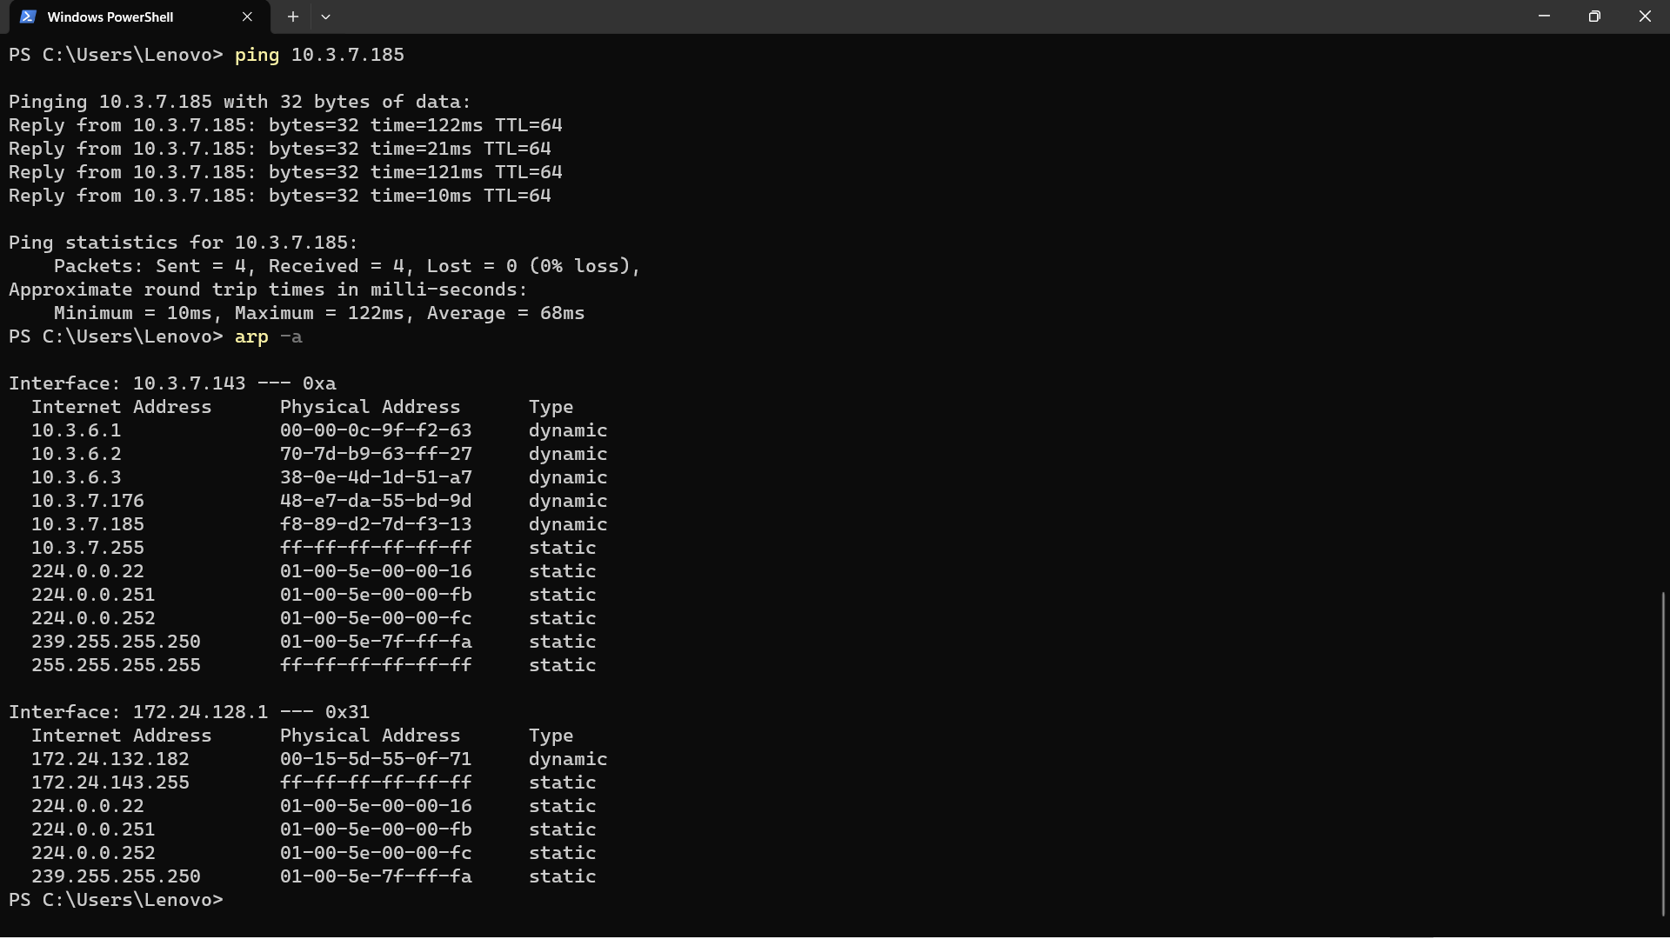

Before Pinging: When you check your ARP cache using arp -a before pinging the target IP address, your ARP cache may not have an entry for the MAC address of that IP because your system hasn't communicated with it recently.

After Pinging: After you ping the target IP address, your system will send out an ARP request to discover the MAC address associated with that IP. Once the ARP request is successful and the MAC address is obtained, your system updates its ARP cache with the new entry. So, when you check your ARP cache again using arp -a after pinging, you should see a new entry in the cache that maps the IP address to the MAC address.

Q11🡪

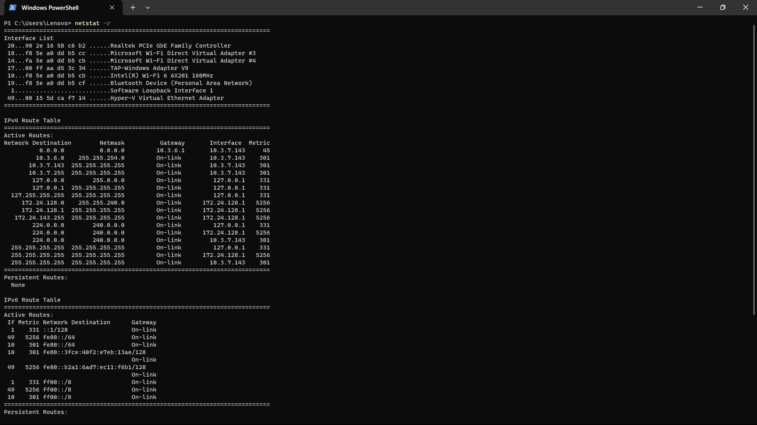

MAC address: f8 5e a0 dd b5 cb

Q12🡪

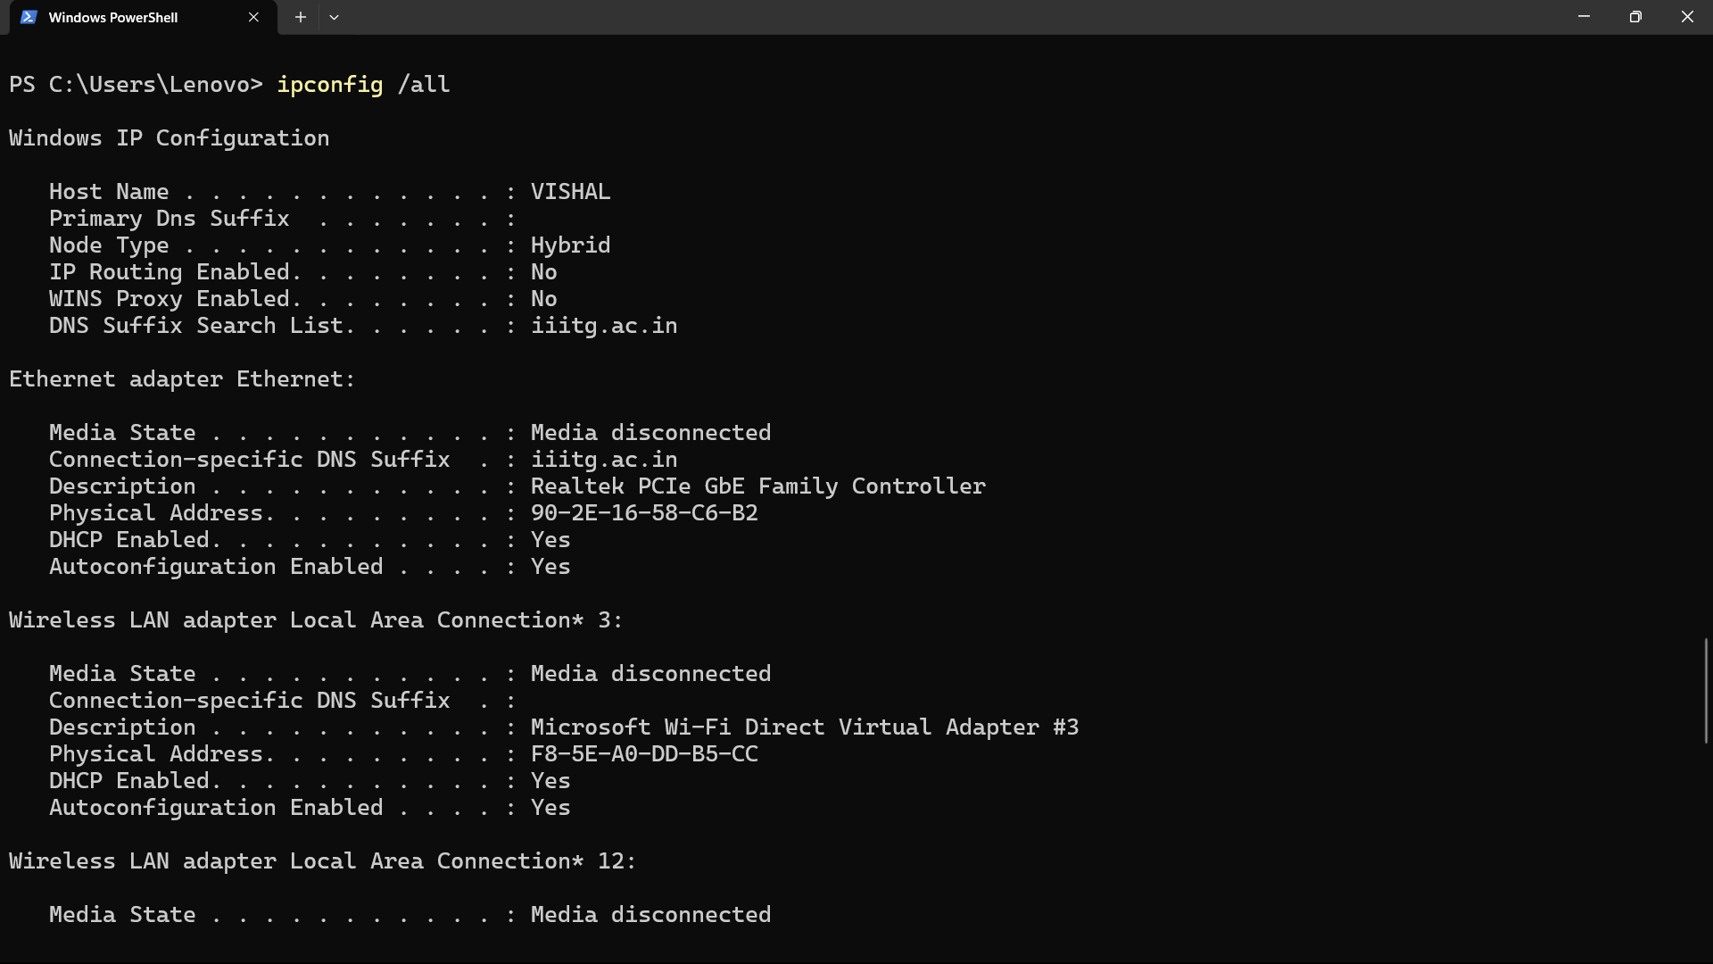

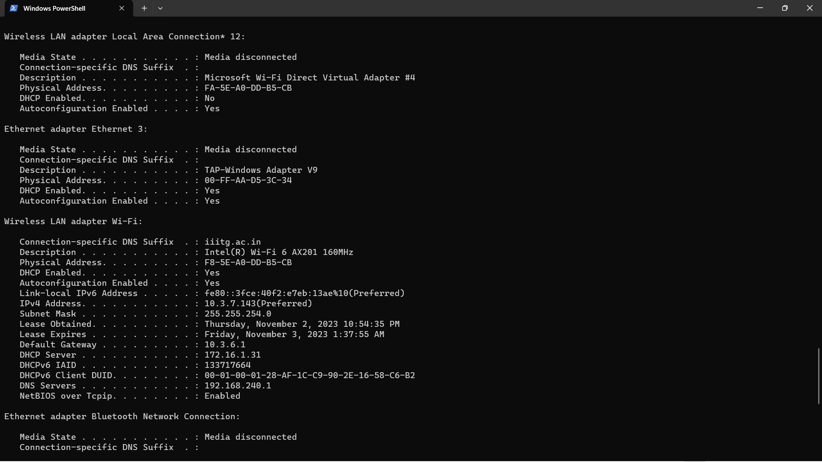

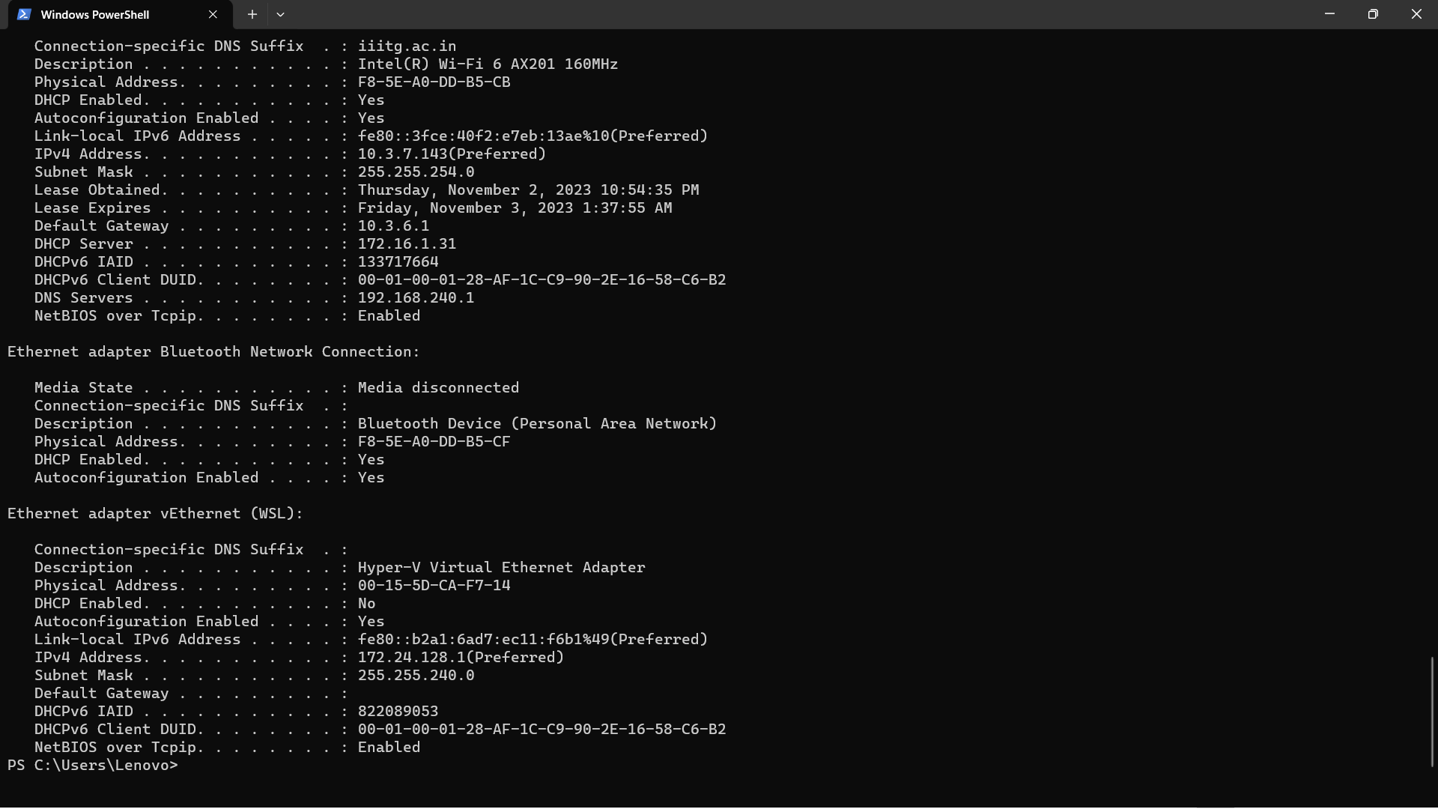

Q13🡪

